Participating Consortium Members of Res-AGorA
Ms. Bryndum is a Sociologist and a project leader at the Danish Board of Technology Foundation.
Currently she is primarily engaged with the design and implementation of five stakeholder workshops for the Res-AGorA project on Responsible Research and Innovation.

Nina Bryndum
Danish Board of Technology Foundation
 |  | Mr. Gorgoni has been an Assistant Professor in Legal Theory at Padua University since 2009. He has a Ph.d. in Human Rights from the University of Palermo and a Master's degree in Legal Theory from the European Academy of Legal Theory. Mr. Gorgoni further has a degree in law from the University of Padua and was Admitted to the Bar in 2000. His research focuses on the evolutions of the legal concept of responsibility (in particular notion of prospective responsibility), on the evolution of legal sources and regulation, (in particular new technologies and "Responsible Research and Innovation"). He teaches Legal Theory and Legal Computer Science (School of Political Sciences, University of Padua).
Guido Gorgoni
University of Padua
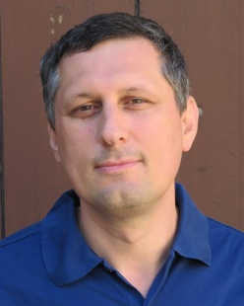 |  | Mr. Griessler studied sociology and history at the University of Vienna. He worked and conducted research at the University of Vienna (1990-1992), the Austrian Research Center Seibersdorf (1992-1995), and the Rijksuniversiteit Limburg (1992-1993). In 1995 he took his doctor's degree. From 1995 to 1999 he worked as junior researcher at the Ludwig-Boltzmann Institute for Medicine and Health Sociology. Since 1999 he works as researcher at the Institute for Advanced Studies in Vienna.  Research areas include Citizen Participation in Research and Innovation, ELSA of Life Sciences and RRI.
Erich Griessler
Institute for Advanced Studies
 |  | Mr. Ibsen-Jensen is a project assistant at the Danish Board of Technology working on the two EU funded projects SATORI and Res-AGorA and has a bachelor degree in Geography.  He is currently studying at the Master of Climate Change at the University of Copenhagen.
Jakob Ibsen-Jensen
Danish Board of Technology Foundation
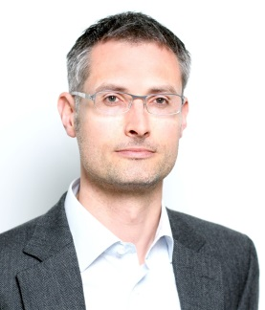 |  | Mr. Lindner is a senior researcher at the Department of Emerging Technologies of the Fraunhofer Institute for Systems and Innovation Research ISI in Karlsruhe. In this function, Dr. Lindner has participated in and coordinated a number of large national and European research projects in the field of technology and innovation policy. These projects include BIOPOLIS, an inventory and analysis of national public policies that stimulate research in life sciences and biotechnology. Ralf Lindner is the coordinator of the Res-AGorA project and is involved in a number of research activities directly related to responsible research and innovation.
Ralf Linder
Fraunhofer Institute
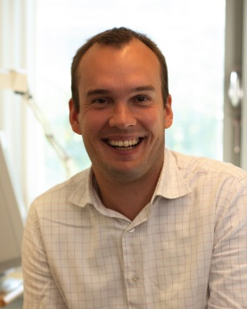 |  | Mr. Mejlgaard is a Ph.D. and director of the Danish Center for Studies in Research and Research Policy at Aarhus University.  His work focuses on science policy, governance, and communication, with particular interests in ‘scientific citizenship’, public participation and perceptions of science and controversial technologies. Mr. Mejlgaard has coordinated several Danish research projects on science policy and public participation, been lead scientific partner in the recent FP7 project on ‘Monitoring Policies and Research Activities on Science in Society in Europe’ (MASIS) and has been actively involved in several other European projects relating to responsible research and innovation
Niels Mejlgaard
Aarhus Universitet

 |  | Mr. Velsing Nielsen is a PhD fellow at the Danish Board of Technology and Roskilde University working on issues of research and innovation governance. His work is focused on the creation of dialogue across institutional and disciplinary boundaries. He has a master in Public Administration and has earlier worked on issues of human rights in Europe.
Morten Velsing Nielsen
Danish Board of Technology Foundation
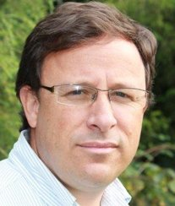 |  | Mr. Ordóñez is assistant professor at the Department of Science, Technology, and Policy Studies (STəPS), University of Twente. He is PhD in Public Policy of the Georgia Institute of Technology and the Georgia State University, USA. He is a Research Associate at the Technology Policy and Assessment Center –TPAC of the Georgia Institute of Technology in Atlanta, and at the Centro de Investigaciones y Proyectos Especiales of the UEC in Bogota, Columbia. His research interests include i Science, Technology and Innovation Policy Design, as well as on Policy Performance and Impact Assessment Methods.
Gonzalo Ordóñez-Matamoros
University of Twente
 |  | Ms. Randles is Senior Research Fellow at the University of Manchester Institute of Innovation Research (MIOIR). Her current research focuses on responsible innovation highlighting implications for policy, governance and society. As Principal Investigator for the University of Manchester on the (2009) FP7, NANOPLAT project she was WP leader researching value chains in nano-consumer products and distributed governance, and collaborated with the National Institute for Consumer Research on the Norwegian Research Council funded project NANOCONSUMER (2008).
Sally Randles
The University of Manchester
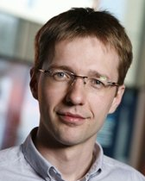 |  | Mr. Walhout is researching governance processes, frameworks and discourses of emerging technologies. At the University of Twente he is working on the project “Practices, Institutionalisation and Impact of Responsible Innovation in Nanotechnology”, which is part of the Risk Analysis & Technology Assessment (RATA) theme of the research consortium NanoNextNL.  Previously Mr. Walhout worked as a Technology Assessment (TA) practitioner at the Rathenau Institute. Bart Walhout has a background in innovation policy studies and radio electronics. He has a special interest in the political dynamics of new and emerging science and technology (NEST).
Bart Walhout
University of Twente
Workshop Facilitator
 |  | Mr. Mandl is senior lecturer at the Faculty of Business, Economics and Statistics, University of Vienna as well as principal of the management consulting firm Mandl, Lüthi & Partner. He supports funding agencies as well as enterprises on all issues related to innovation and technology management.
Christoph Mandl
University of Vienna

